**Introduction:**

The XR4000 parts and connections are given below

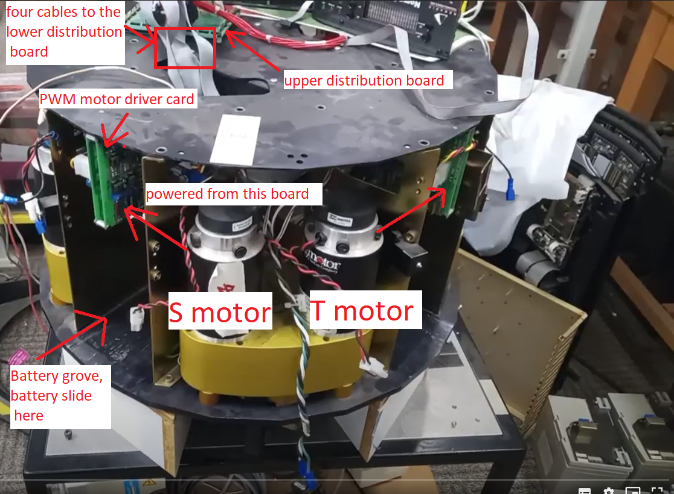

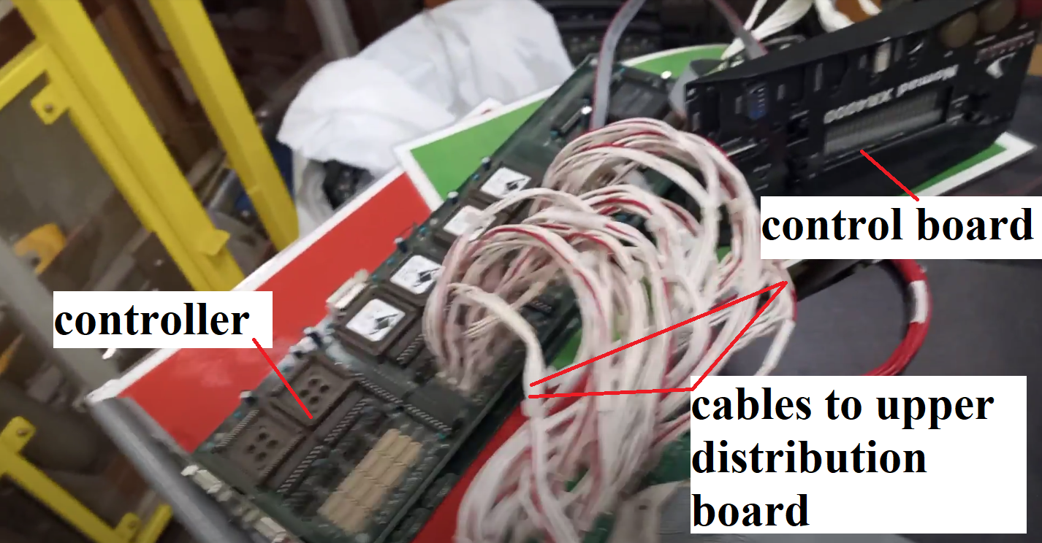

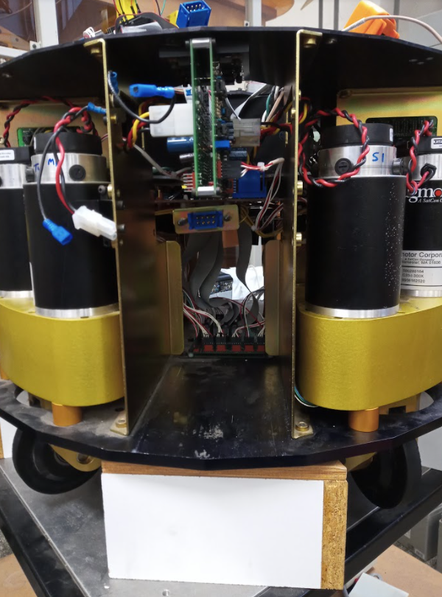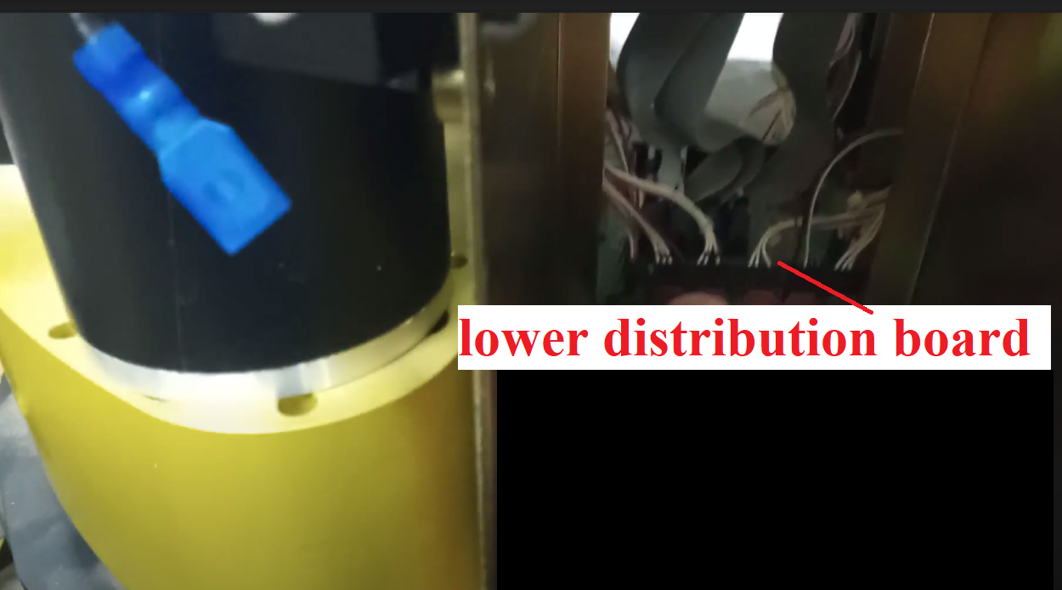

**Fig. 1 XR 4000**

**To paypass the logic board and make the power supply deliver power to the motor drivers, we need to hotwire like this**

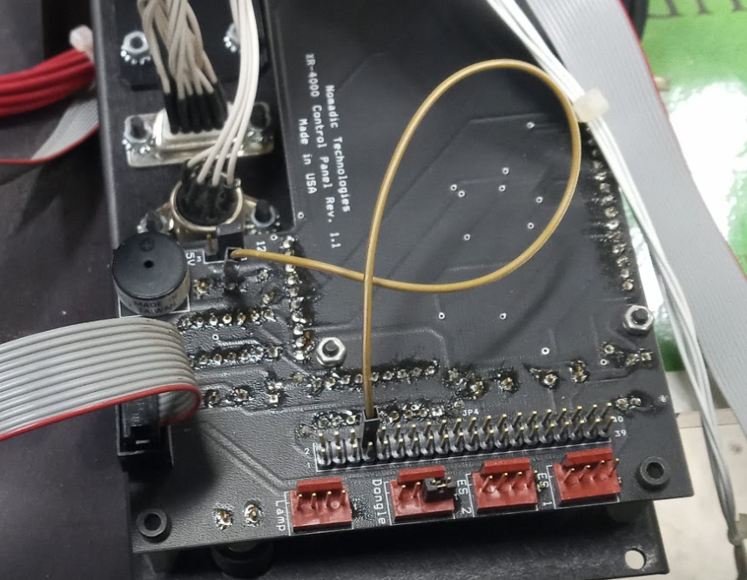

**Fig. 2** control board hotwire to bypass the logics and start the robot instantaneously

**Connections:**

XR-4000 has two distribution boards to distribute the signals to and from the motors.

All the motors, encoders and home sensors are connected to the lower distribution board. and four IDC cables connect this lower distribution board to the upper one.

The upper distribution board has test pins that can be used to test and access to various signals.

These test pins are arranged in groups Encoder, Signal, and Home. Then group of cables are connected to this upper distribution board.

The cables naming is based on motor1, motor2 , .., motor8

The testing pins naming are based on s1, s2, s3, s4, T1, T2, T3, T4.

S: Spin (change the direction/orientation)

T: Turning (make the wheel rotate, make the robot move)

The mapping between the two is given by:

| Motor 1 | T4 |
| --- | --- |
| Motor 2 | T3 |
| Motor 3 | T2 |
| Motor 4 | T1 |
| Motor 5 | S4, Home4 |
| Motor 6 | S3, Home3 |
| Motor 7 | S2, Home2 |
| Motor 8 | S1, Home1 |

For each connector, pin 1 is marked as 1 on the PCB as below:

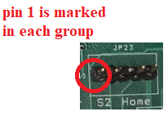

**Motors connections:**

The connections that are labeled under motor1 to motor8 see the image below (the cables) , are given by:

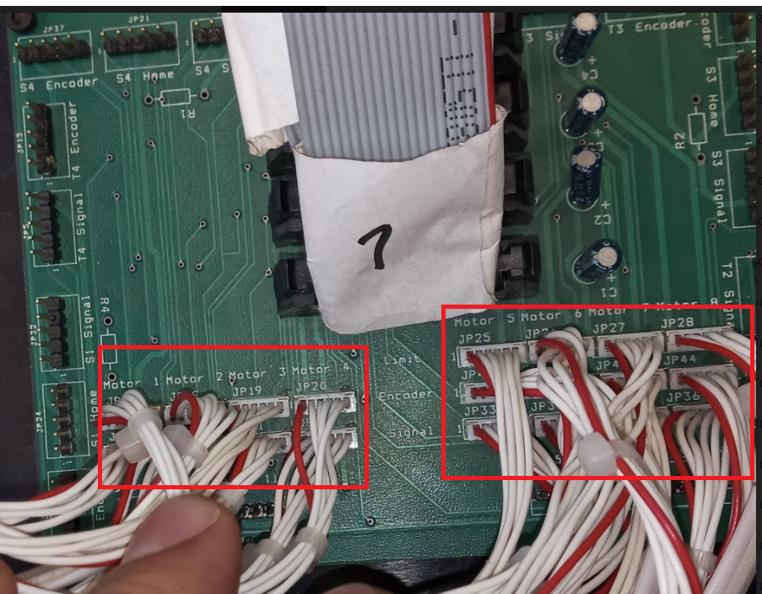

**Fig. 2:** The cables connections labeled with limit, encoder, signal and grouped into Motor 1, Motor 2 , …, Motor 8. (NC: No connection)

| Limit (Motor 5 to 8) | | | | | | |
| --- | --- | --- | --- | --- | --- | --- |
| Signal name | GND | NC | GND | NC | VCC | Out |
| Pin number | 1 | 2 | 3 | 4 | 5 | 6 |

| Encoder (Motor 1 to 8) | | | | | | |
| --- | --- | --- | --- | --- | --- | --- |
| Signal name | GND | NC | A | +5v | B | GND |
| Pin number | 1 | 2 | 3 | 4 | 5 | 6 |

| Signal (Motor 1 to 8) | | | | | | |
| --- | --- | --- | --- | --- | --- | --- |
| Signal name | PWM | DIR | NC | +5v | GND | NC |
| Pin number | 1 | 2 | 3 | 4 | 5 | 6 |

**The test pins:**

The test pins are shown below in red boxes

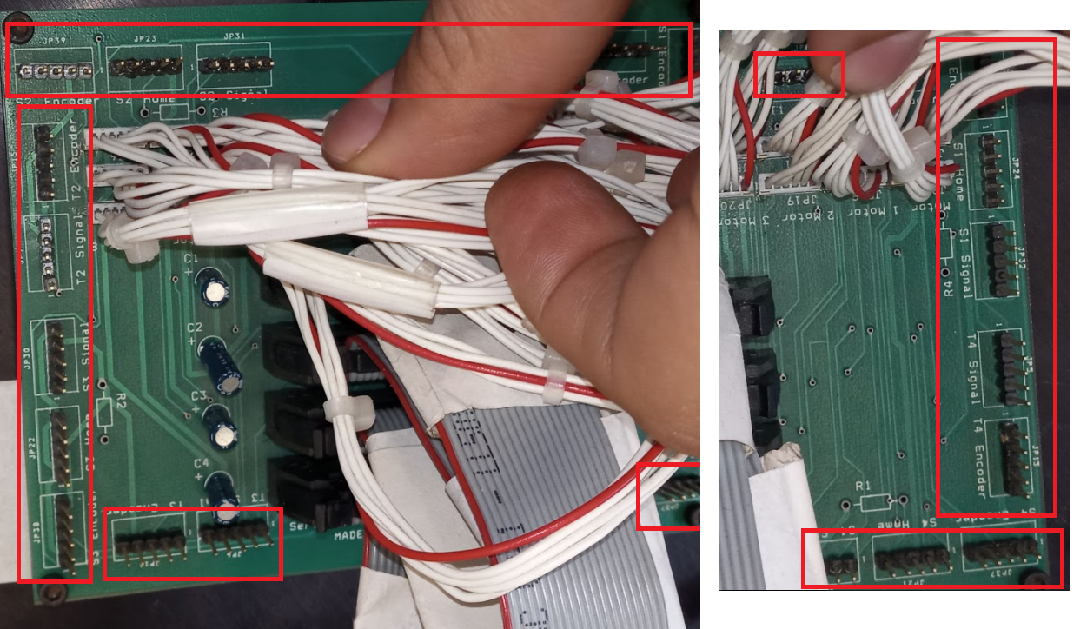

**Fig. 3:** Test pins labeled as Home, Encoder, Signal and grouped as S1 to S4, T1 to T4.

| Home (S1 to 4/T1 to 4 test pins) | | | | | |
| --- | --- | --- | --- | --- | --- |
| Signal name | GND | Output | Vcc | NC | GND |
| Pin number | 1 | 2 | 3 | 4 | 5 |

| Encoder (S1 to 4/T1 to 4 test pins) | | | | | |
| --- | --- | --- | --- | --- | --- |
| Signal name | GND | NC | A | +5v | B |
| Pin number | 1 | 2 | 3 | 4 | 5 |

| Signal (S1 to 4/T1 to 4 test pins) | | | | | |
| --- | --- | --- | --- | --- | --- |
| Signal name | PWM | DIR | NC | +5v | GND |
| Pin number | 1 | 2 | 3 | 4 | 5 |

**Home sensor:**

The home sensor is OPB 940W51, and it is located at the bottom of the robot next the wheel. The purpose of this sensor is to set the orientation of the robot at the start of the robot operation. There is a lever that pass through the sensor to block the light and hence provide a signal to the controller that this is the home position of the wheel. When the wheels are at the home position, they will be at 90deg from each other.

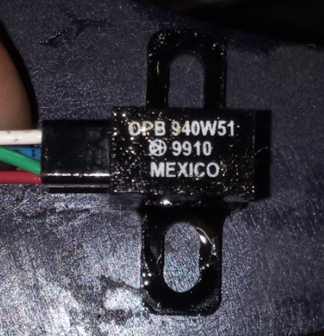

**Fig. 4:** Home sensor photo

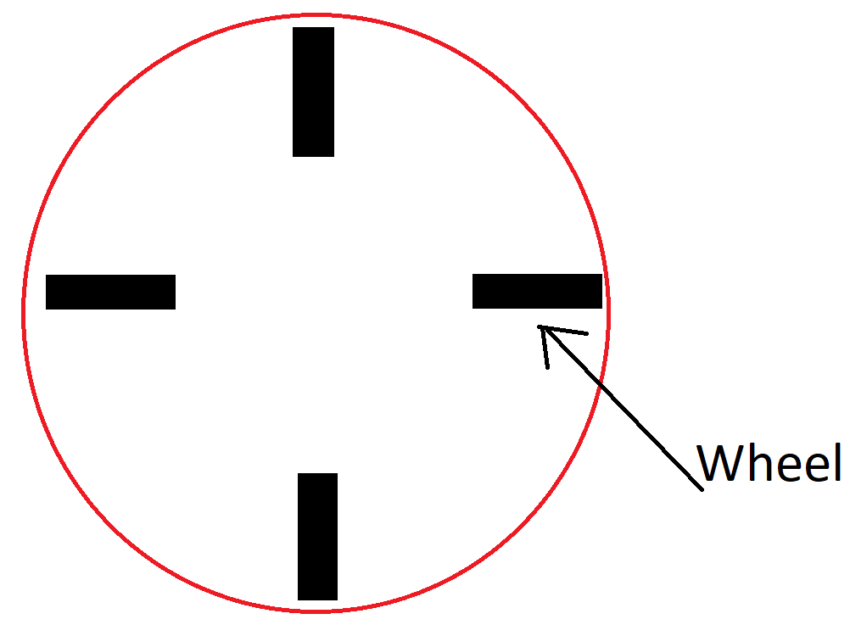

**Fig. 5:** Robot wheels at the start position

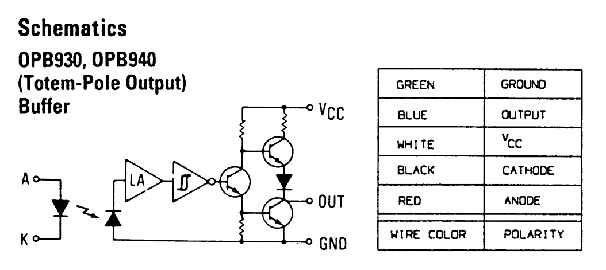

**Fig. 6:** Sensor schematic and wires color codes

**Note:** there is a resistor in the lower distribution board that connect VCC to Anode

Home sensor location is shown below:

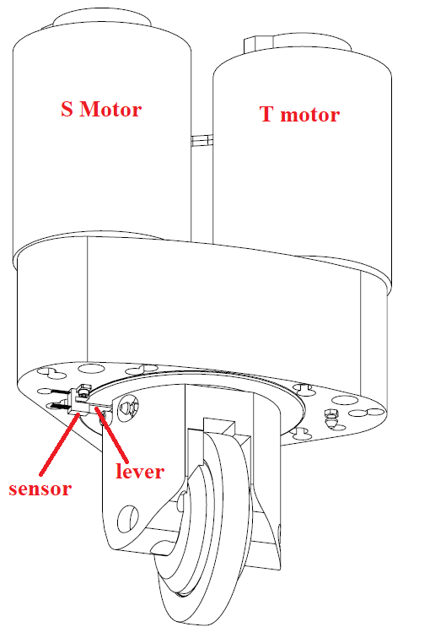

**Fig. 7:** Home sensor location

Sensor datasheet:

[https://drive.google.com/file/d/1_R8WC7Z1bM3ls5EhkgNrfnRupHx_ueWk](https://drive.google.com/file/d/1_R8WC7Z1bM3ls5EhkgNrfnRupHx_ueWk/view?usp=sharing)

**Encoders:**

The encoders are from US Digital: E3-2048-250

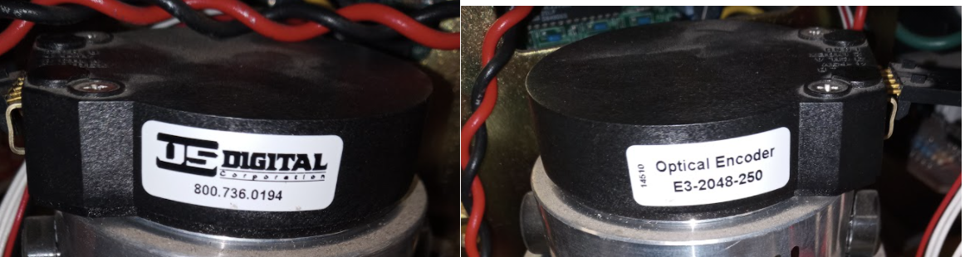

**Fig. 8** Encoder image

Encoder data sheet:

[https://drive.google.com/file/d/1PAKr5_U-YcIdWsi-Zj_hOhmKOJaWdl-8](https://drive.google.com/file/d/1PAKr5_U-YcIdWsi-Zj_hOhmKOJaWdl-8/view?usp=sharing)

**Motors:**

Motors are Magmotor C33-i-300x

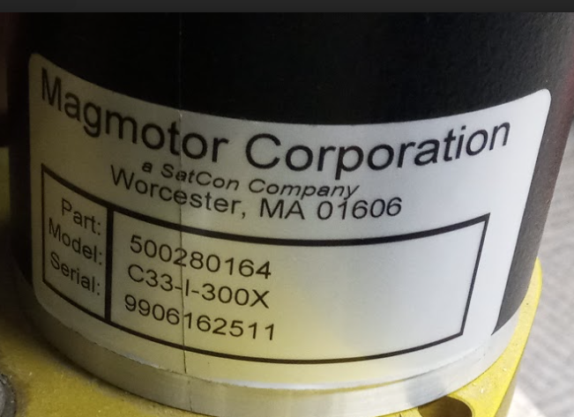

**Fig. 9** Motor image

Motor data sheet:

<https://drive.google.com/file/d/1k2FLCunWHm7hjtFe5wZzUHPzAsqtTzvx>

**Nominal voltage: 12 V**

**Cont. Current: 3 Amp**

**Peak Current: 24 Amp**

**Motor drivers:**

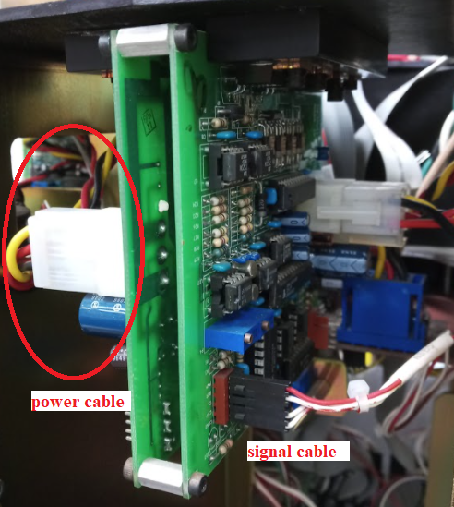

**In the signal cable the red wire is PWM**

Power cable:

Yellow: 24 V high power to the motors

Red: 5 V for the logics

Black: Ground

Testing the driver:

For the power, connect the following:

Yellow: 24 V power supply

Red: 5 V power supply

Black: Ground (connect the ground of the two power supplies together)

In the S/T test pins connect:

PWM: to Arduino PWM signal pin 3

DIR: to Arduino digital out pin 4

VCC: +5v to Arduino +5v

GND: Arduino GND and connect Arduino GND to the power supply ground

Give HIGH or LOW to DIR, to test direction, and some signal (0 to 255) to PWM to test the speed.

Send commands through serial monitor:

**List of commands**

d0 : direction 0

d1 : direction 1

p0 to p255 : pwm with value 0 to 255

**Arduino Code:**

String command;

int pwmValue;

const int DIR = 4;

const int PWM = 3;

void setup() {

Serial.begin(9600);

pinMode(DIR, OUTPUT);

pinMode(PWM, OUTPUT);

}

void loop() {

if (Serial.available()) {

command = Serial.readStringUntil('\n');

if (command.equals("d0")) {

Serial.println("d0 recieved");

digitalWrite(DIR, LOW);

}

else if (command.equals("d1")) {

Serial.println("d1 recieved");

digitalWrite(DIR, HIGH);

}

else if (command.charAt(0) == 'p') {

pwmValue = command.substring(1, command.length()).toInt();

Serial.println("p recieved " + String(pwmValue));

if (pwmValue >= 0 and pwmValue <= 255)

{

analogWrite(PWM, pwmValue);

}

else {

Serial.println("Invalid command");

}

}

else {

Serial.println("Invalid command");

}

}

}

Test results for the cards :

S1: Pass

T1: Pass

S2: FAIL

T2: FAIL

S3: FAIL

T3: FAIL

S4: FAIL

T4: FAIL

The motor driver

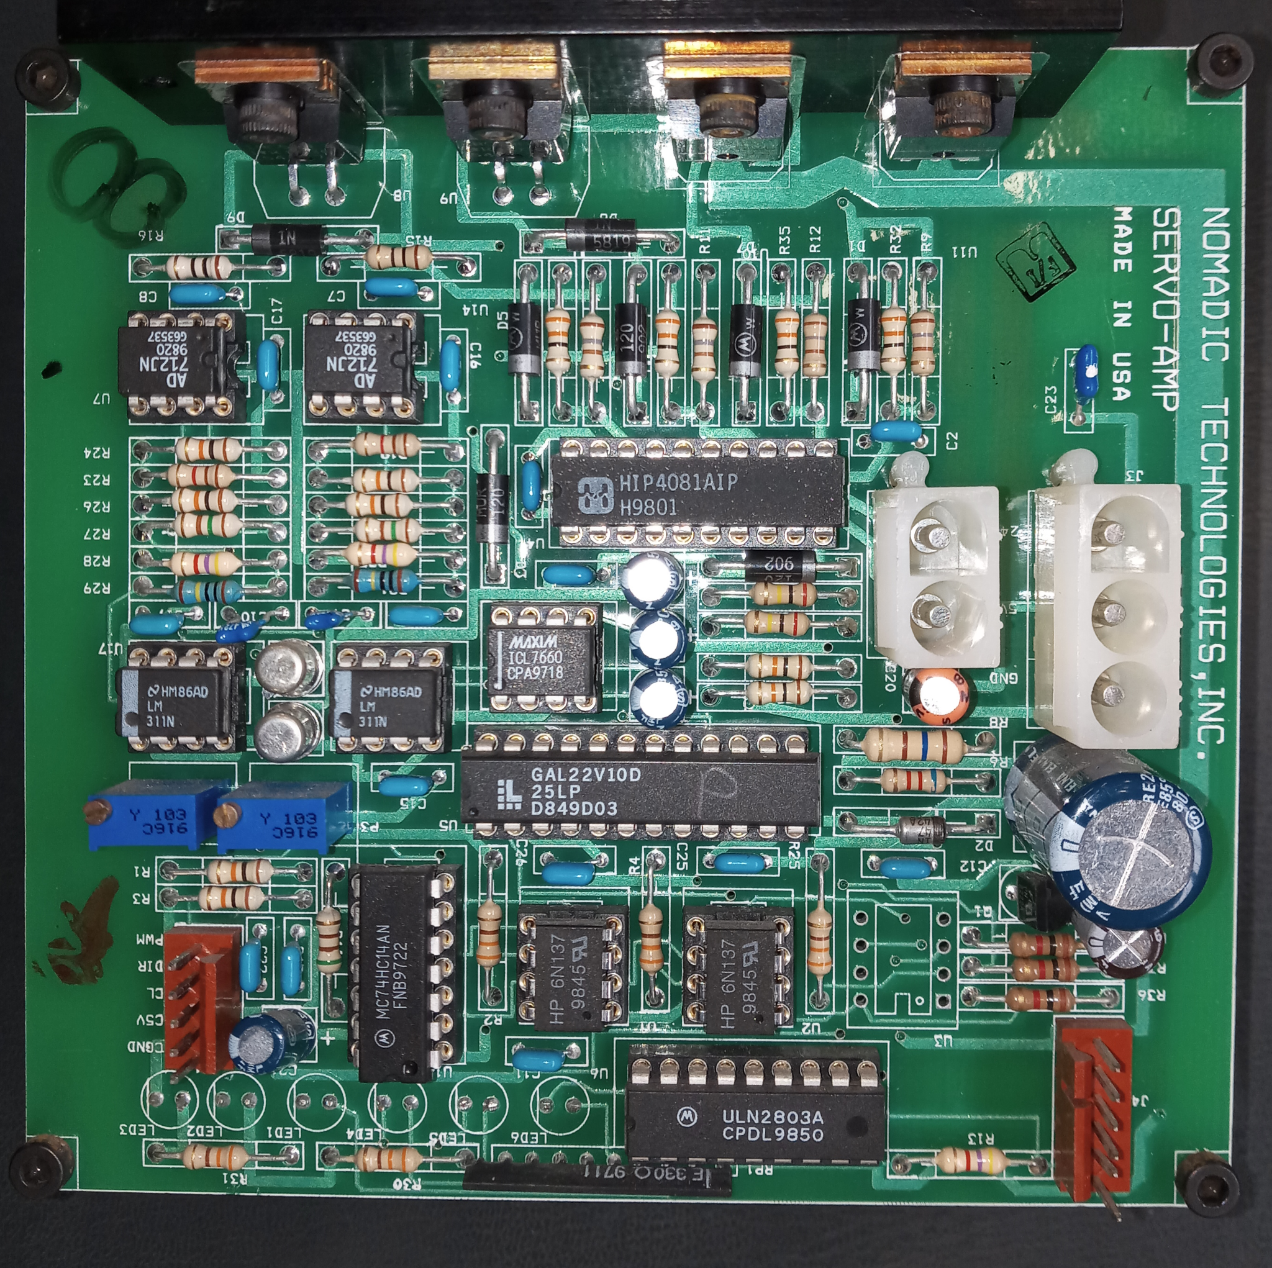

It takes +24 V , 5 V, GND as shown below

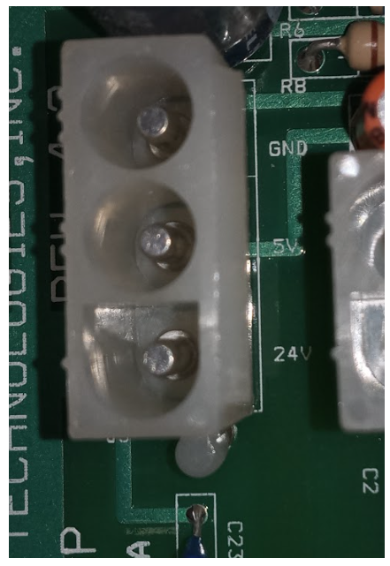

Action:

The motor drivers need replacement.

Four of the following motor driver have been sourced

#2516 Pololu Dual G2 High-Power Motor Driver 24v14 Shield for Arduino

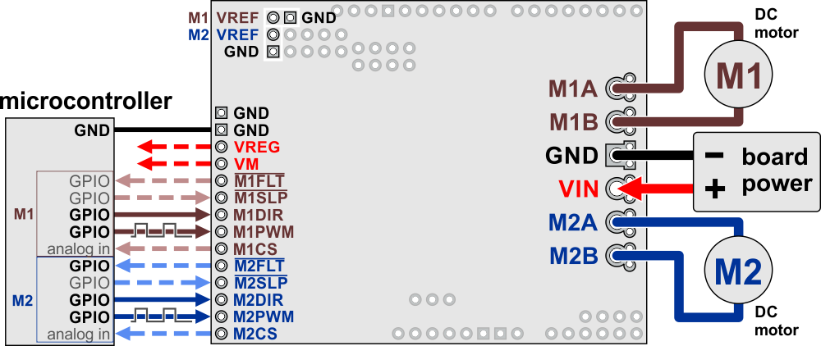

**Documents of this driver:**

<https://drive.google.com/drive/folders/1U4EYvA6gwqRgZKxlkcfw_Q_Ic1YDKrYi>

This table explains what the motor driver’s control and feedback pins are and how they connect to an Arduino when the driver is used as a shield:

| **Motor driver pin** | **Default state** | **Arduino**  **pin** | **Description** |
| --- | --- | --- | --- |
| M1FLT |  | 6 | Fault indicators: These open-drain outputs drive low when a fault is occurring. In order to use these outputs, they must be pulled up to your system’s logic voltage (such as by enabling the internal pull-ups on the Arduino pins they are connected to). See below for details. |
| M2FLT | 12 |
| M1SLP | LOW | 2 | Inverted sleep inputs: These pins are pulled high, enabling the driver by default. Driving these pins low puts the motor driver channels into a low-current sleep mode and disables the motor outputs (setting them to high impedance). |
| M2SLP | 4 |
| M1DIR | LOW | 7 | Motor direction inputs: When DIR is low, motor current flows from output A to output B; when DIR is high, current flows from B to A. |
| M2DIR | 8 |
| M1PWM | LOW | 9 | Motor speed inputs: A PWM (pulse-width modulation) signal on these pins corresponds to a PWM output on the corresponding channel’s motor outputs. When a PWM pin is low, the corresponding motor brakes low (both A and B are shorted together through ground). When it is high, the motor is on. The maximum allowed PWM frequency is 100 kHz. |
| M2PWM | 10 |
| M1CS |  | A0 | Current sense outputs: These pins output voltages proportional to the motor currents when the H-bridges are driving (but not while they are braking, including when current limiting is active). The output voltage is about 10 mV/A for the 18v22 and 20 mV/A for the other versions, plus an approximate offset of 50 mV. |
| M2CS | A1 |
| M1VREF |  |  | Current limit threshold adjustments: A resistor can be connected between VREF and the adjacent GND to lower the current limiting (chopping) threshold from its default setting. See below for details. |
| M2VREF |

The battery system:

4 batteries of 12 V 33 Ah are connected in series.

This connection has issues in charging, and that is some batteries does not charge to the full charge if one battery or more already reached 13.8 V. It needs a circuit to be placed in parallel with each battery.

Here is the circuit diagram:

<https://drive.google.com/file/d/1opk0K-6EtBO11cpZRXQd9a0a85MhGDU1/view?usp=sharing>

Since the power supply is dead, we most likely don’t need to worry about this.

The recommendation is:

Either:

1- use four batteries in series, that is 48 volt then step this down to 24V to supply to the motor drivers.

2- To just use one 24V 33Ah battery that is LI Poly type, instead of four. And have dual mode of power either by power supply or by batteries. A change over switch should be used to switch between the two.

**PCB design:**

A new PCB design will be done to connect all the pwm cables, encoders cables and home cables to the Galil controller.

The connector of Galil 100-pin cable is

Part Number: AMP #2-178238-9

We used the Straight connector type

Part number: [2-5175887-9](https://www.digikey.com/en/products/detail/te-connectivity-amp-connectors/2-5175887-9/1860549)

Link:

<https://www.digikey.com/en/products/detail/te-connectivity-amp-connectors/2-5175887-9/1860549>

5 pin header

<https://www.digikey.com/en/products/detail/te-connectivity-amp-connectors/1-1123723-5/686928>

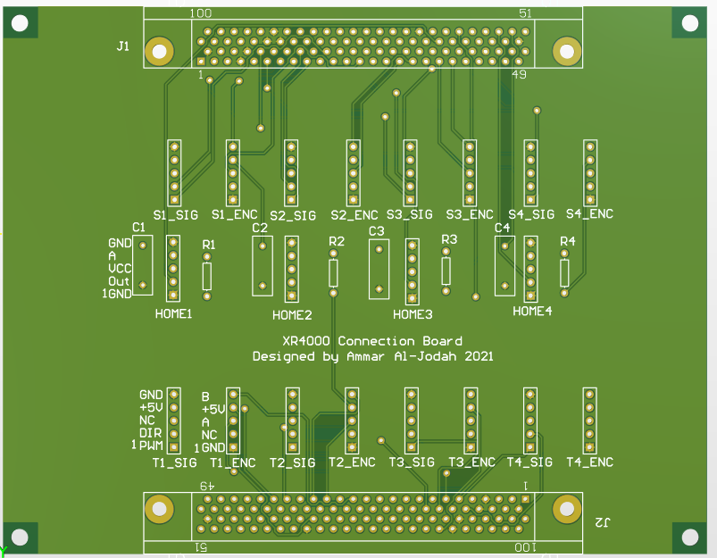

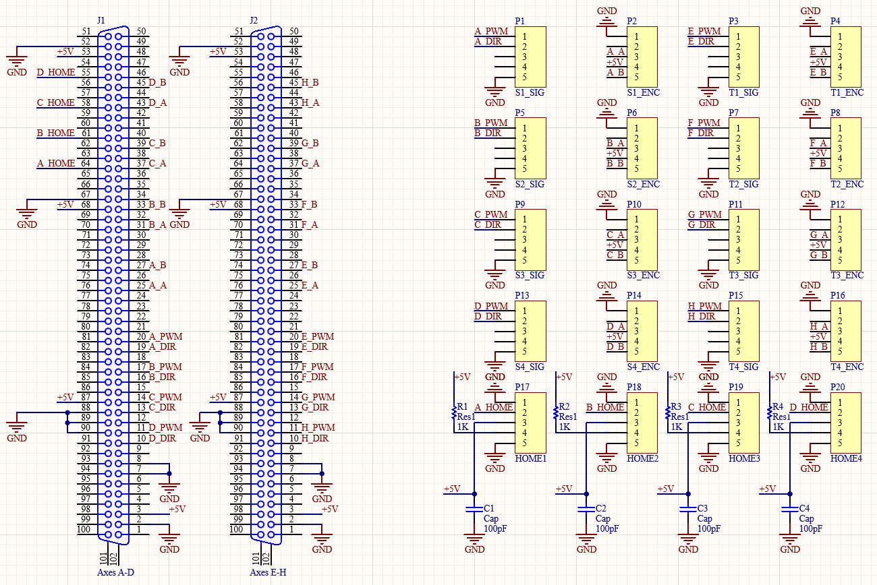

**Size:**

105 mm X 135 mm

Holes diameter 3.3 mm

The space from the edge of the hole is 1.5 mm

Power supply replacement:

<https://www.digikey.com.au/product-detail/en/delta-electronics/DRL-24V240W1AA/1145-1212-ND/6150211>

<https://www.instructables.com/Arduino-Mega-and-Visuino-Connect-AD7606-8-Channel-/>

Due to error in the design of the PCB, the Home2 is connected to input 20 instead of being connected to Home 2 (home of motor B)

Output 2 is used to send signal to activate the relay.

The relay conduct with low.

SB2 Relay off

CB2 Relay on